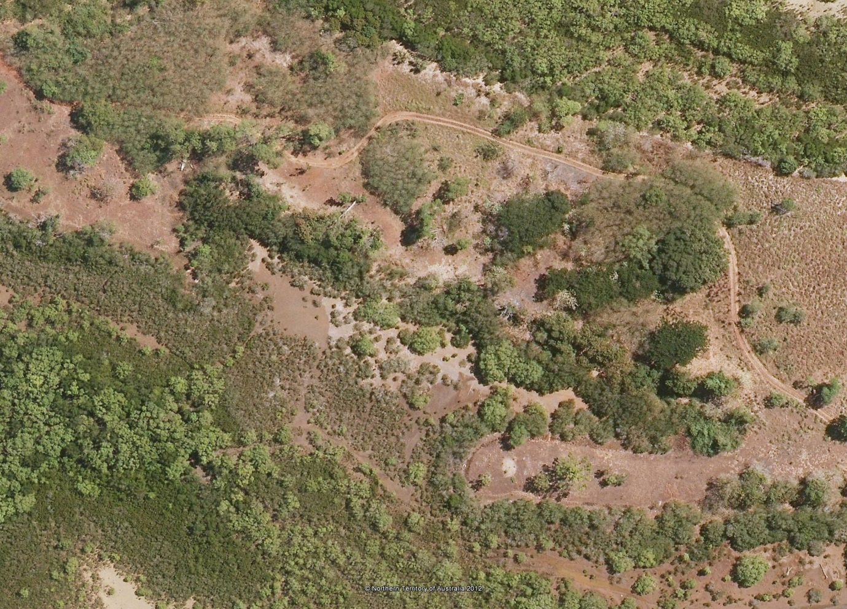
“Fish Camp”, the site of Fred Fogarty’s house, 1975 -1985, on the Kulaluk Lease Area near Ludmilla Creek, Darwin.
Shown in this aerial photograph (2010), top right, is the vehicle track extending from Totem Road to Ludmilla Creek. The track bends sharply around a weeping fig tree. The introduced tree is a remnant of Fred Fogarty’s garden and tree planting project. This tree was also the location of Bob Bundawabi’s camp in 1996-7. Where the track straightens out it is shaded by a clump of invasive Coffee Bush. In the top left, sheets of tin, remnants of one of Fred’s earlier houses, 1973-4, can be seen. Lower left and centre are the mangroves surrounding the extensive tidal Ludmilla Creek system. Fred Fogarty built his last substantial house on the thumb of high ground jutting into the mangroves (lower right). The light-coloured spot at the end of the thumb of land indicates the location of the house, demolished after Fred’s sudden death. In the 1970s and 1980s there was a well-worn foot track through the mangroves passing Fred’s camp and leading from Ludmilla to the fishing and crabbing grounds in the creek, also widely used for recreation (see Henderson, K, ‘Kulaluk Land Use Field Study’ [1983]). Parts of the track and its branches can still be seen in the aerial photograph. Fred’s body was found on the foot track. Hand painted signs at the end of the thumb of land indicated that tides of 8 metres almost reached the house (description written by Bill Day 2019). Top right are the mangroves surrounding the salt pan as it was in 1985, later excavated for a prawn farm (abandoned [1999) and then a crab farm (also abandoned [2006]).

